**Project Documentation: Food Ordering Application**

**1. General Information about the Project**

**Project Name: Food Delivery Management System**

**Description:**

**The goal of the project is to develop a client-server application that supports the processes in a food delivery company – from the registration of clients, restaurants, and couriers to the management of orders, deliveries, and revenue reports.**

**2. Business Model (Lean Canvas)**

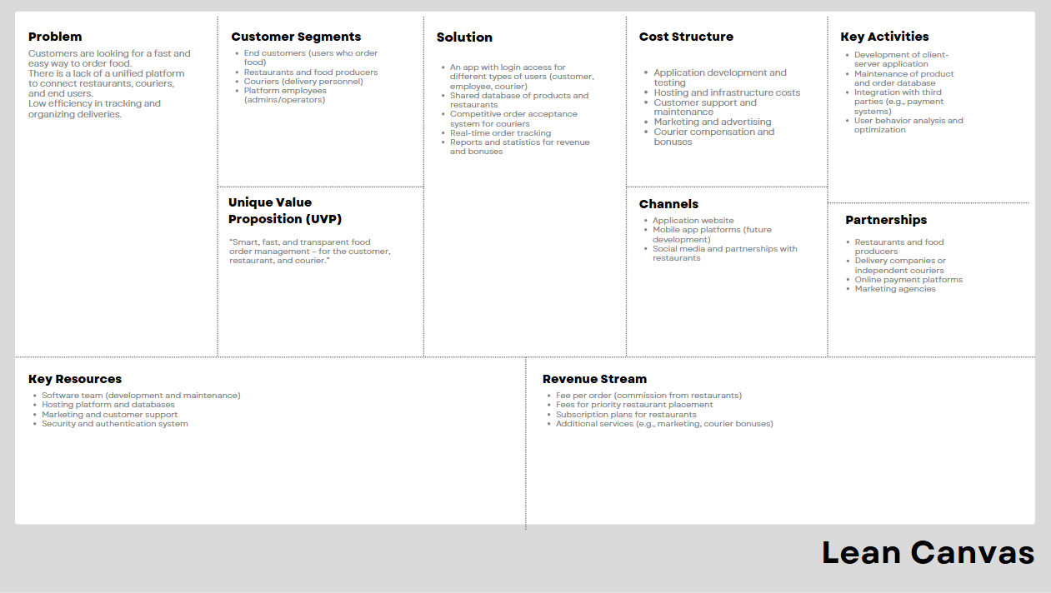

**3. Features**

**For Clients:**

* **Registration and login**
* **Browsing and filtering food items by category**
* **Creating orders**
* **Tracking order status**

**For Employees:**

* **Adding/editing/deleting restaurants and products**
* **Generating revenue reports**
* **Managing users and deliveries**

**For Couriers:**

* **Accepting orders**
* **Tracking deliveries**
* **Receiving bonuses upon reaching revenue targets**

**4. System Architecture**

**Type: Client-server application**

**Client: Console interface (GUI – optional, as a bonus)**

**Server: REST API / local server / file exchange via SQL**

**Data Formats: SQL**

**Multiple Users: Supports concurrent usage (multi-user mode)**

**5. *Database Diagram***

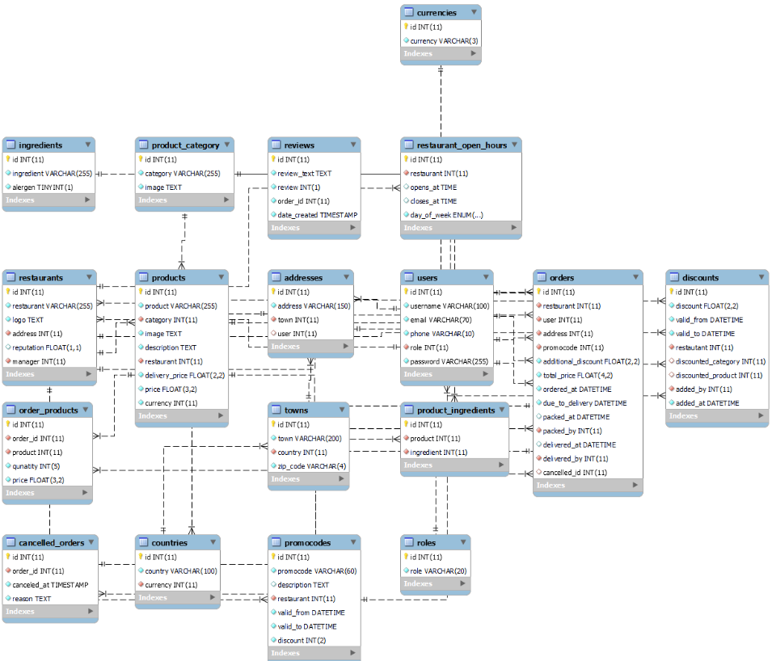

**6. Application Requirements**

* **Interface: GUI**
* **Data Formats: Database**
* **Error Handling: Optional exception handling – e.g., for invalid registration, failed login, order errors**
* **Multi-user Mode: Support for multiple clients and employees working simultaneously**

**7. Potential Libraries and Technologies**

* **Language: Java**
* **User Interface: GUI**
* **Files: SQL**
* **Server: Spring Boot (Java)**

**8. Testing**

* Unit tests for business logic (registration, orders, calculations)
* Integration tests between modules
* Edge cases (empty fields, incorrect password, rejected orders)